**Lab Manual for Computer Communication and Networking**

**Lab No. 08**

**Routing Information Protocol(RIP)**

**BAHRIA UNIVERSITY KARACHI CAMPUS**

**Department of Software Engineering**

**COMPUTER COMMUNICATION & NETWORKING**

**LAB EXPERIMENT # 08**

Dynamic Routing RIP

**OBJECTIVE: -**

* This lab assignment helps in understanding how dynamic route using Routing Information Protocol (RIP) can be configured on routers.

**THEORY: -**

Routing Information Protocol (RIP) is a true distance-vector routing protocol. RIP sends the complete routing table out to all active interfaces every 30 seconds. RIP only uses hop count to determine the best way to a remote network, but it has a maximum allowable hop count of 15 by default, meaning that 16 is deemed unreachable. RIP works well in small networks, but it’s inefficient on large networks with slow WAN links or on networks with many routers installed. It cannot distinguish between high bandwidth link and a lower bandwidth link because delay or bandwidth is not taken under consideration as a metric.

**NETWORK TOPOLOGY: -**



**PROCEDURE AND OBSERVATION: -**

**Step01: Configuring RIP routing on router 1**

Router1(config)#interface serial 0/0/0 (Configuring serial 0 port)

Router1(config-if)#ip address 15.0.0.1 255.0.0.0

Router1(config-if)#Clock rate 64000

Router1(config-if)#no shut

Router1(config-if)#exit

Router1(config)#interface fa 0/0 (Configuring fastethernet 0 port)

Router1(config-if)#ip address 10.0.0.3 255.0.0.0

Router1(config-if)#no shut

Router1(config-if)#exit

Router1(config)#router rip (Configuring RIP on router 1)

Router1(config)#network 10.0.0.0

Router1(config)#network 15.0.0.0

Router1# show ip route

**Step 02: Configuring static routing on router 2**

Router2(config)#interface serial 0/0/0 (Configuring serial 0 port)

Router2(config-if)#ip address 15.0.0.5 255.0.0.0

Router2(config-if)#Clock rate 64000

Router2(config-if)#no shut

Router2(config-if)#exit

Router2(config)#interface fa 0/0 (Configuring fastethernet 0 port)

Router2(config-if)#ip address 20.0.0.3 255.0.0.0

Router2(config-if)#no shut

Router2(config-if)#exit

Router1(config)#router rip (Configuring RIP on router 2)

Router1(config)#network 20.0.0.0

Router1(config)#network 15.0.0.0

Router2# show ip route

**Step03: Verify the route by pinging from Router 1 to Router 2**

Router2# ping 20.0.0.2 or

Router1# ping 10.0.0.2

**Step04: Verify the route by pinging from PC 1 to PC3**

C:\> ping 10.0.0.1 (from PC 1) or

C:\> ping 20.0.0.2 (from PC 3)

**QUESTIONS: -**

1. **Configure RIP on the following network and show all necessary configuration steps for each router.**



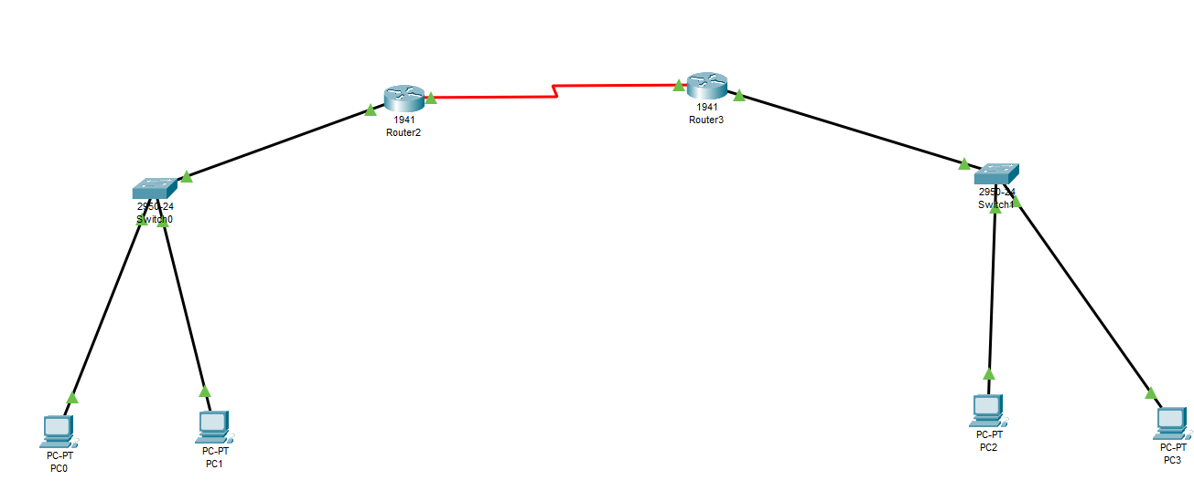

**Router 0**

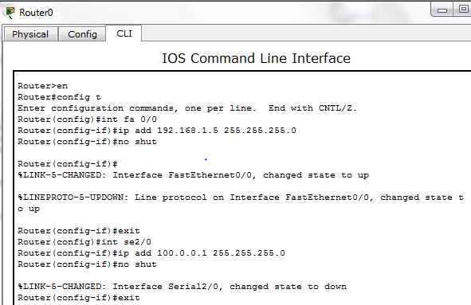

**Router 1**

**Pinging:**

1. **Configure RIP on the following network and show all necessary configuration steps for each router.**



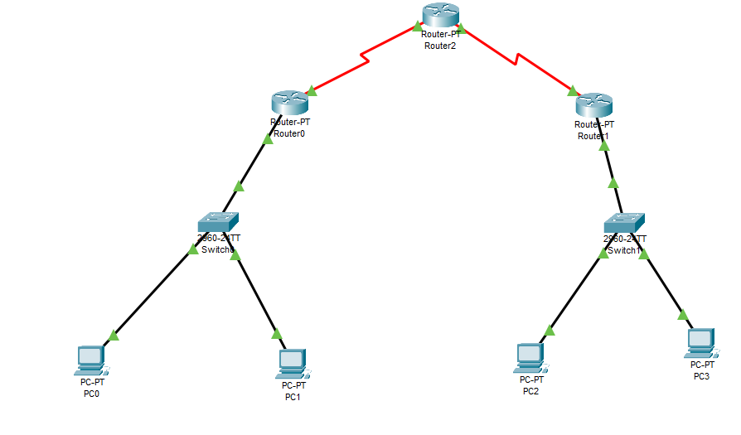

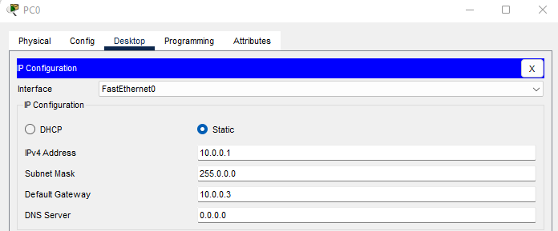

**Router 0**

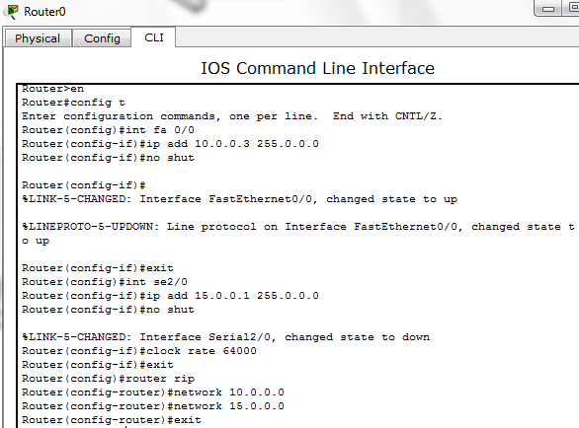

**Router 1**

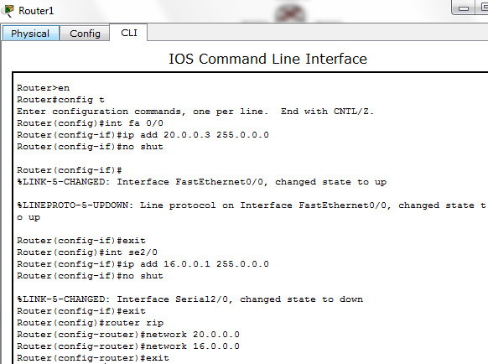

**Router 2**

**Pinging:**

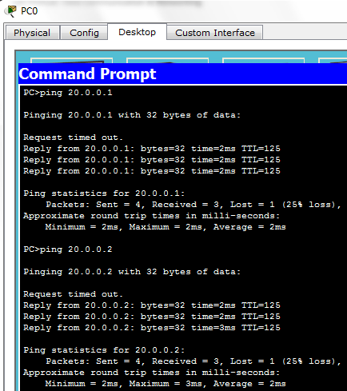

**TIME BOXING:**

|  |  |  |
| --- | --- | --- |
| **Activity Name** | **Activity Time** | **Total Time** |
| **Instruments Allocation + Setting up Lab** | 10 mints | 10 mints |
| **Walk through Theory & Tasks (Lecture)** | 60 mints | 60 mints |
| **Implementation & Practice time** | 90 mints | 80 mints |
| **Evaluation Time** | 20 mints | 20 mints |
|  | Total Duration | 180 mints |

**Teacher Signature**: ________________________

**Student Registration No**: ____________________